**FROM SINGLE-CHANNEL TO OMNICHANNEL**

For selling products you commonly cover different distribution channels. Based on consistent single-source product information, multiple channels enable you to scale your sales activities. Even more, you can integrate and orchestrate your marketing activities across multiple channels.

**Single Channel**

A single channel can be a unique communication channel, which is for information only, or a unique commerce channel through which goods, services, and information flow from vendor (or manufacturer, distributor) to consumer (or business customer, dealer, distributor). Such a transactional commerce channel, can be online (web site, electronic catalog) or offline (store, printed material). Hybris provides tools like for feeding information into channels and other tools for implementing the channels themselves, for example a web shop, a mobile shop, a print catalog, or an electronic catalog.

**Multi Channel**

Multi channel is the concept of offering not just one communication or commerce channel to your consumers (or business customers, dealers) but multiple. In order to ensure consistent information like product information, pricing, or promotions in all channels, a single source of truth of product data is mandatory. This is achieved by a Product Information Management System (PIM) that tightly integrates with channel specific applications. SAP Hybris Commerce with its strong PIM component enables you to centrally manage product data. In addition, you easily can add channels like e-catalogs, Point of Sales (POS) kiosk systems, mobile web shops, or call center applications extending the options of SAP Hybris Commerce and Hybris Print.

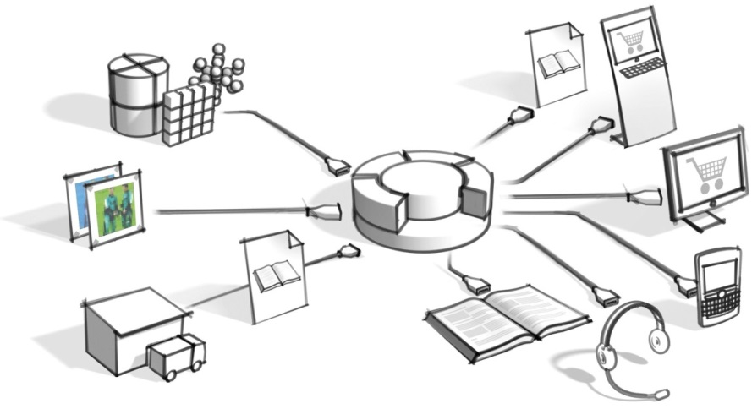

Figure: Schema of the SAP Hybris Commerce. The input channels are on the left, the output channels on the right.

## Cross Channel

Based on a consistent multi channel infrastructure, companies can start guiding customers pro-actively from one channel to the other by means of loyalty programs, store events, vouchers, gift cards, special channel specific promotions, and more. If a consistent multi channel infrastructure is not in place this would only confuse customers, due to disparate and often conflicting product information, availability, and pricing information.

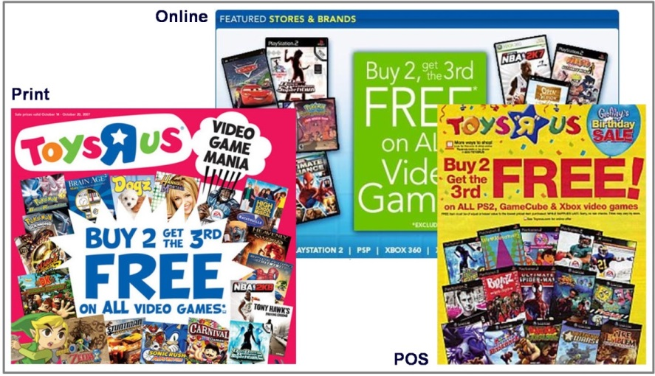

Figure: Cross-channel campaigns require consistent information not only about products but also about promotions.

Customers tend to use all channels simultaneously. For example, having the printed catalog on their desk, a customer orders a product via web shop, that is picked up and paid for in a local retail shop. Such a cross-channel approach supports and reinforces the natural behavior of customers and consumers.

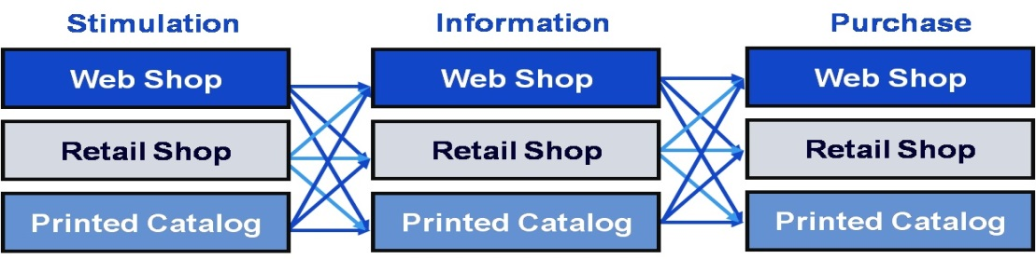

Figure: Cross-channel hopping customers tend to use use different channels (symbolized by horizontal layers) for stimulation, information, and purchase.

Based on SAP Hybris Commerce, you can orchestrate your complementary or channel specific marketing activities, and thus leverage your business across all distribution channels.

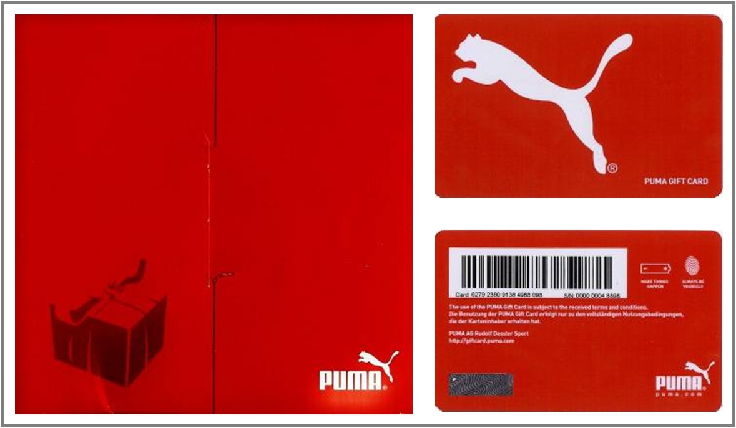

Figure: A sample gift voucher loaded online but valid in both online and offline channels.

## Omnichannel

Physical and digital commerce are converging at an incredible pace—driven by highly connected customers who demand experiences that adapt to their mode of purchasing and shopping. This opens the door for a new imperative known as OmniCommerce, which favors a customer-centric approach over channel-specific processes. The number of customer touch points is exploding and innovation and agility are critical factors for business success. Today, you need to be able to seamlessly sell and communicate consistently across online stores, smart phones, tablets, social networks, and any Internet-enabled device.

Hybris allows for a pure omni channel customer experience. Our platform gives the customer a single view of the merchant across digital and physical commerce.